Name : Kshitij V Darwhekar

Roll No: TETB19

Sub : Soft Computing

Q1. Perform following task on any dataset

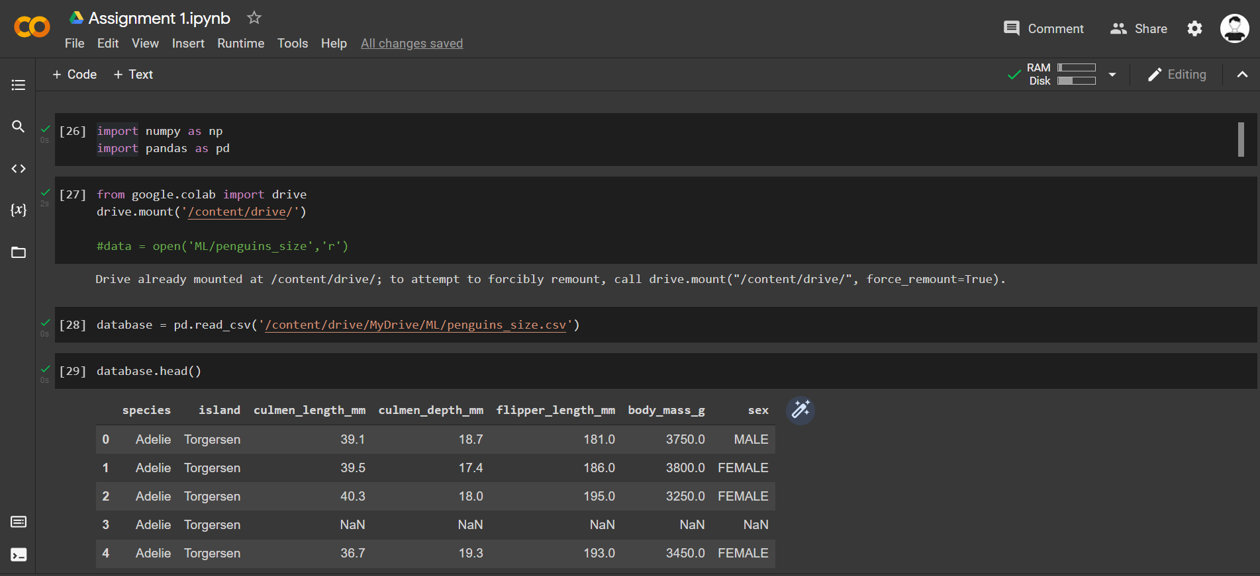

1. Change column name present in dataset

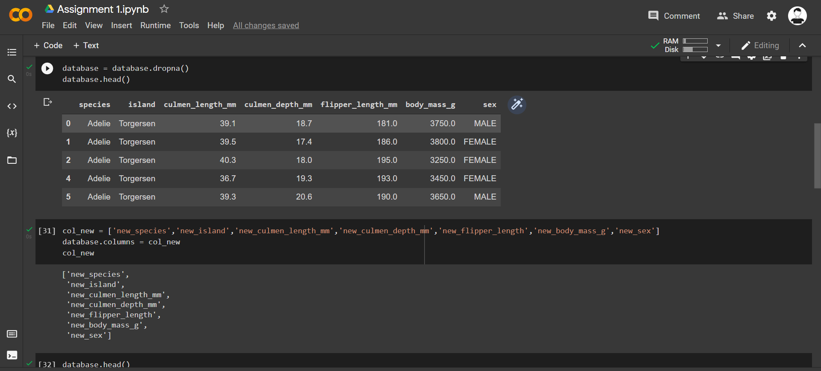

1. Drop unessential column

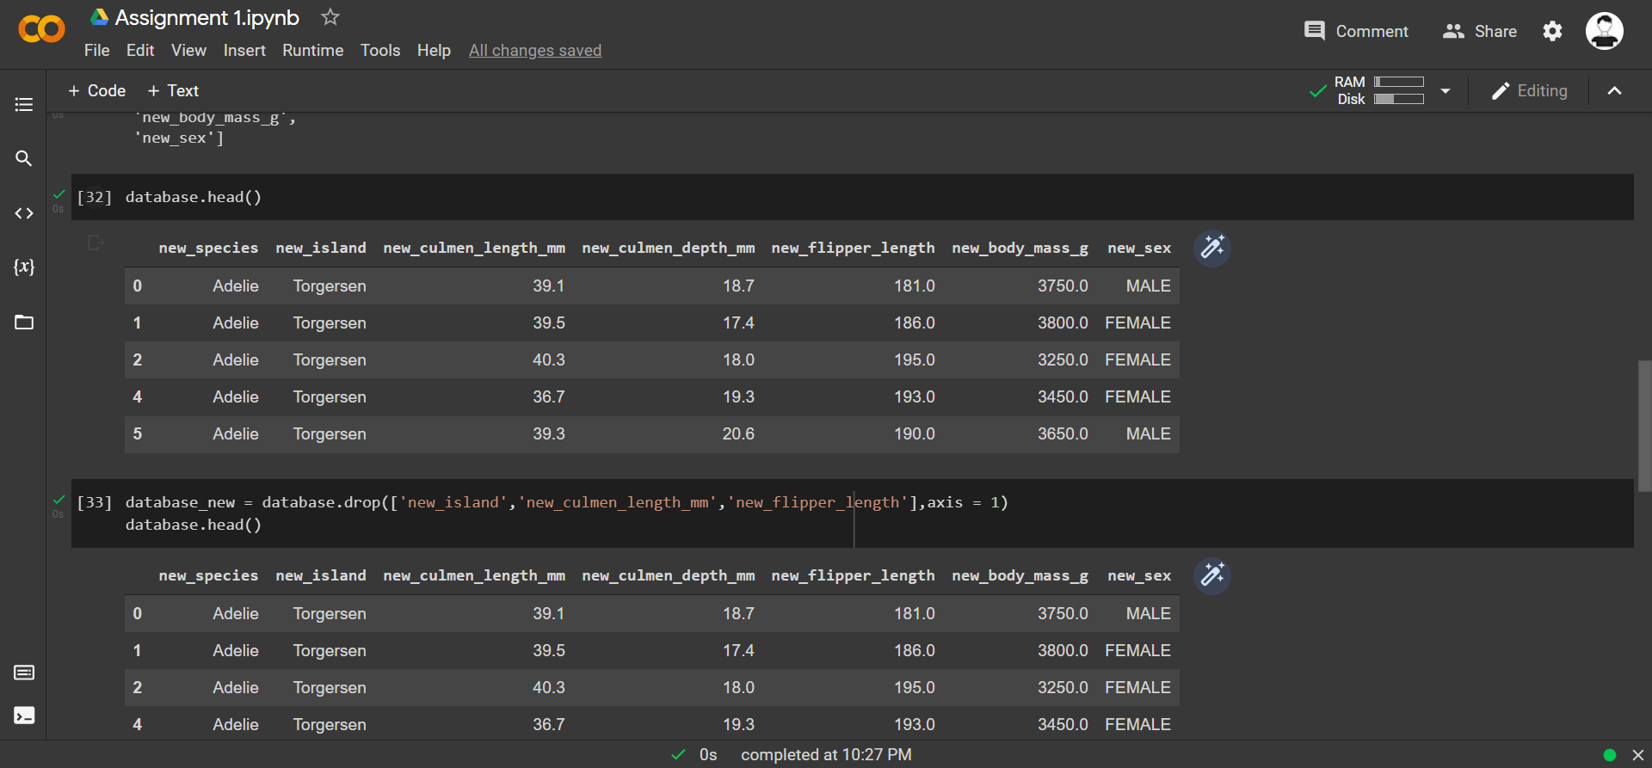

1. Add new columns in dataset

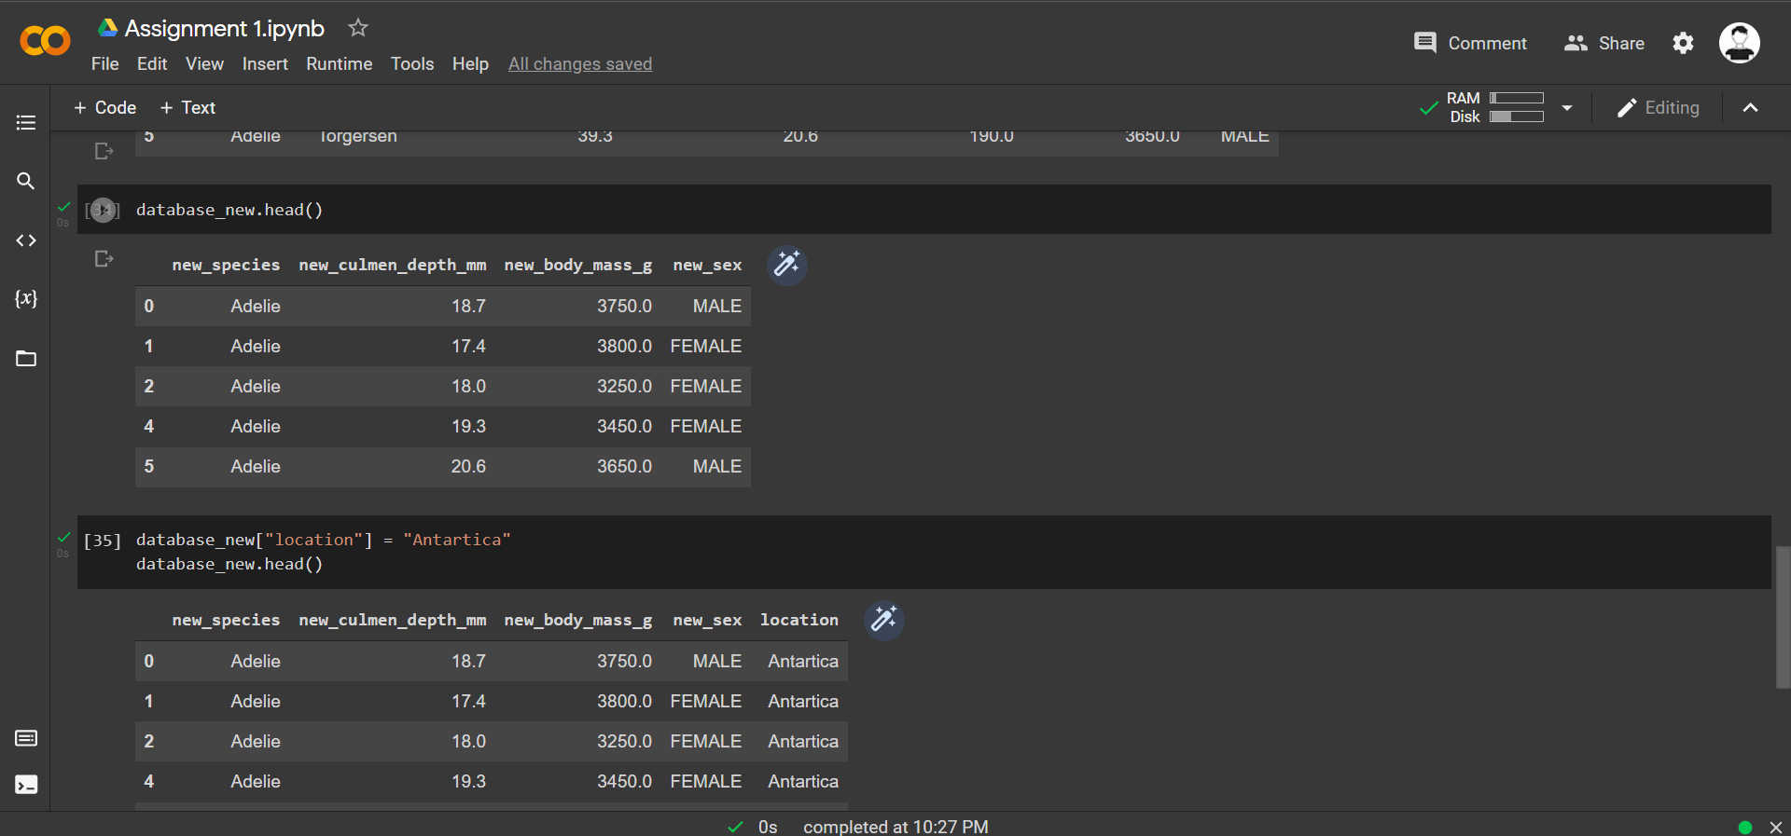

Q2. Explain overfitting, underfitting and confusion matrix with example

1. Select appropriate dataset

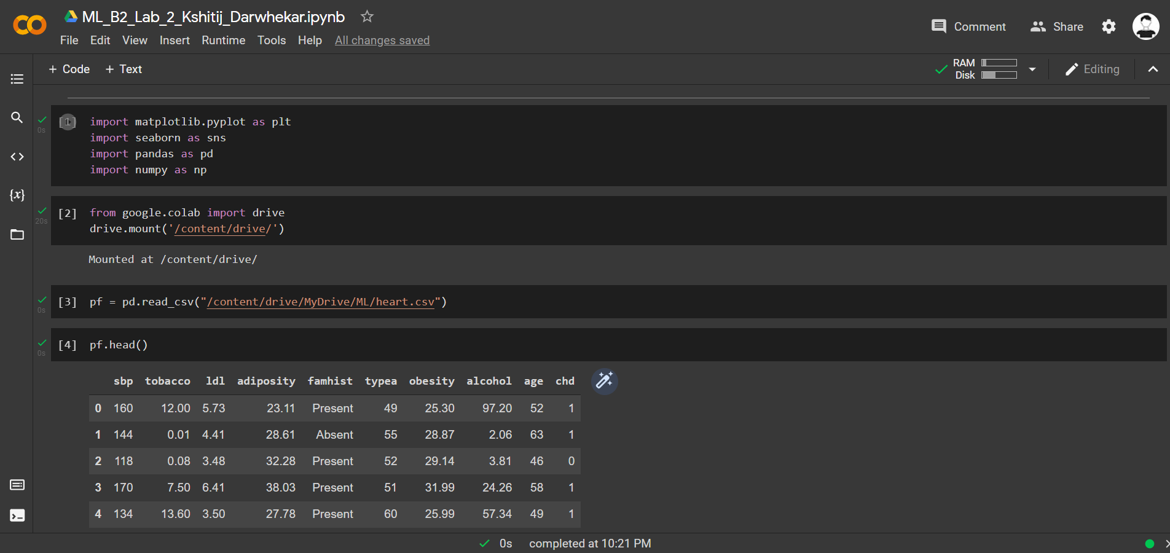

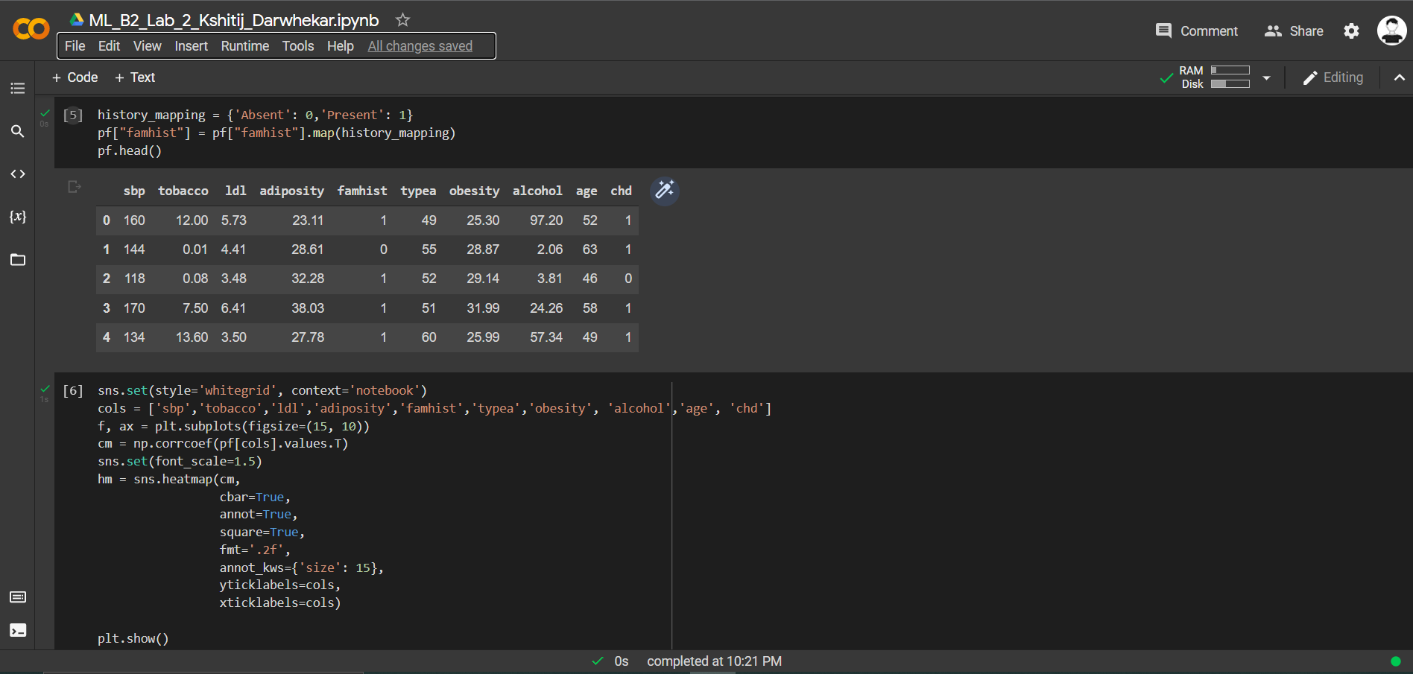

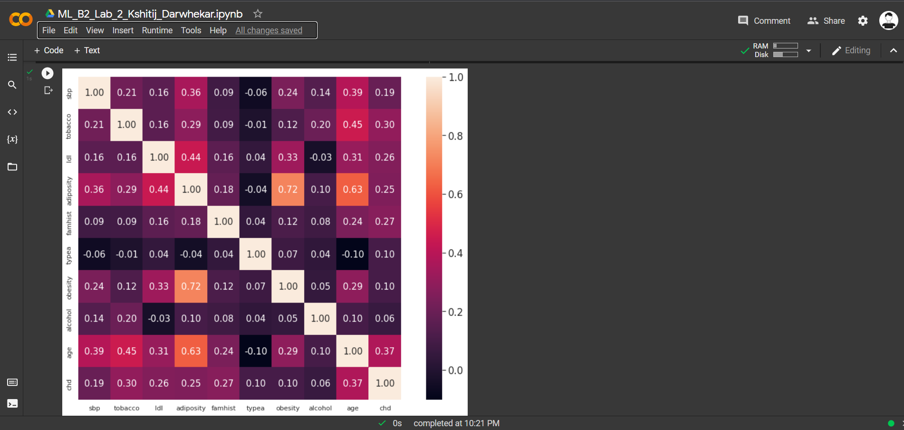

1. Find confusion matrix present analysis

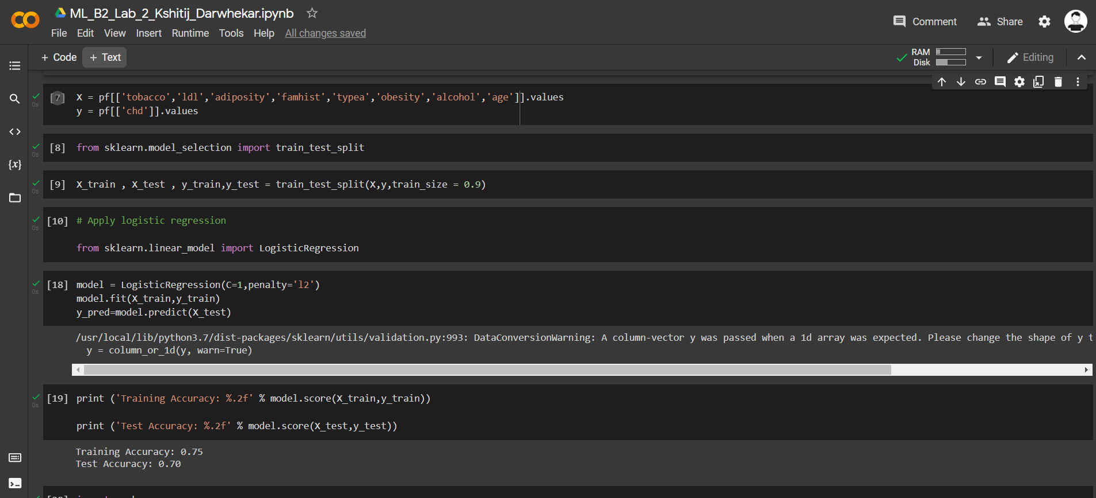

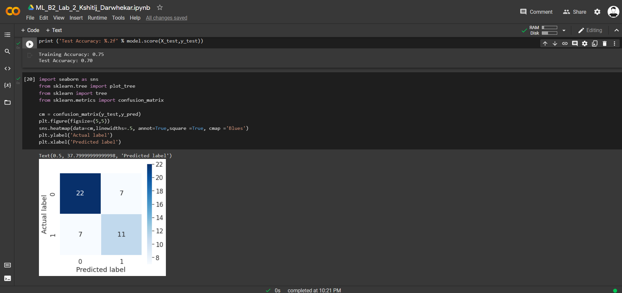

1. Analyze overfitting of model

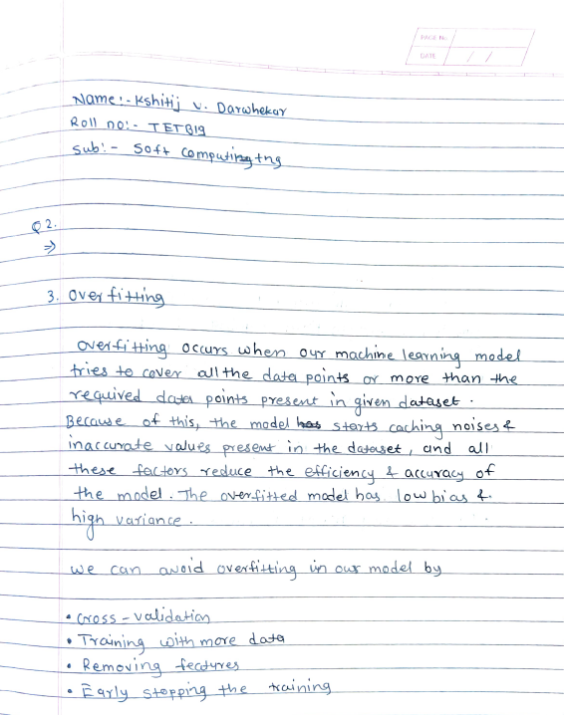

1. Analyze underfitting of model

